Metal Manufacturer Redefines Architectural Possibilities With Unmatched Aesthetics For Traditional Board And Batten Siding

Western States Metal Roofing Adds Metal Board and Batten Panel To Fall Offering

Phoenix, AZ (Aug 7, 2023): Today, Western States Metal Roofing, an industry leader in manufacturing unprecedented design innovations for metal cladding, announces it is gearing up to unveil a design revelation that merges the charm of traditional craftsmanship with the boldness of contemporary aesthetics found with the introduction of its new BB-12.0® Metal Board and Batten siding panel.

In a world where design evolution is paramount, metal board and batten promises to stand as the ultimate design choice for architects, designers, and contractors who are eager to break away from the norm. The aesthetic appeal and advantages of today’s modern metal panels has long been a feature missing for this type of panel that has been echoed for years by professional builders who prefer to handle metal over wood, when architectural design specifications call for board and batten. The choice is unanimous among builders across the industry when asked if only metal siding materials should be used on larger building projects.

When asked about the plans to release board and batten panels in the Fall, it was determined that the scheduled release date in September was set intentionally to build anticipation and align with the company's planned presence at the Western Roofing Expo in Las Vegas, September 24-25, 2023. Western States Metal Roofing new metal board and batten panels will be on full display inside their newer, much larger Booth #342 inside the Paris Hotel and Casino’s exhibitor halls.

“Metal board and batten is about to revolutionize the way you view siding projects. ,” says Stacy Rubio, Vice President of Sales at Western States Metal Roofing.

Ms. Rubio continues, “It's not just a replacement for wood; it's a disruption that's going to redefine the way architects and builders approach building materials when planning for the more popular features found on jobs with a modern farmhouse design.”
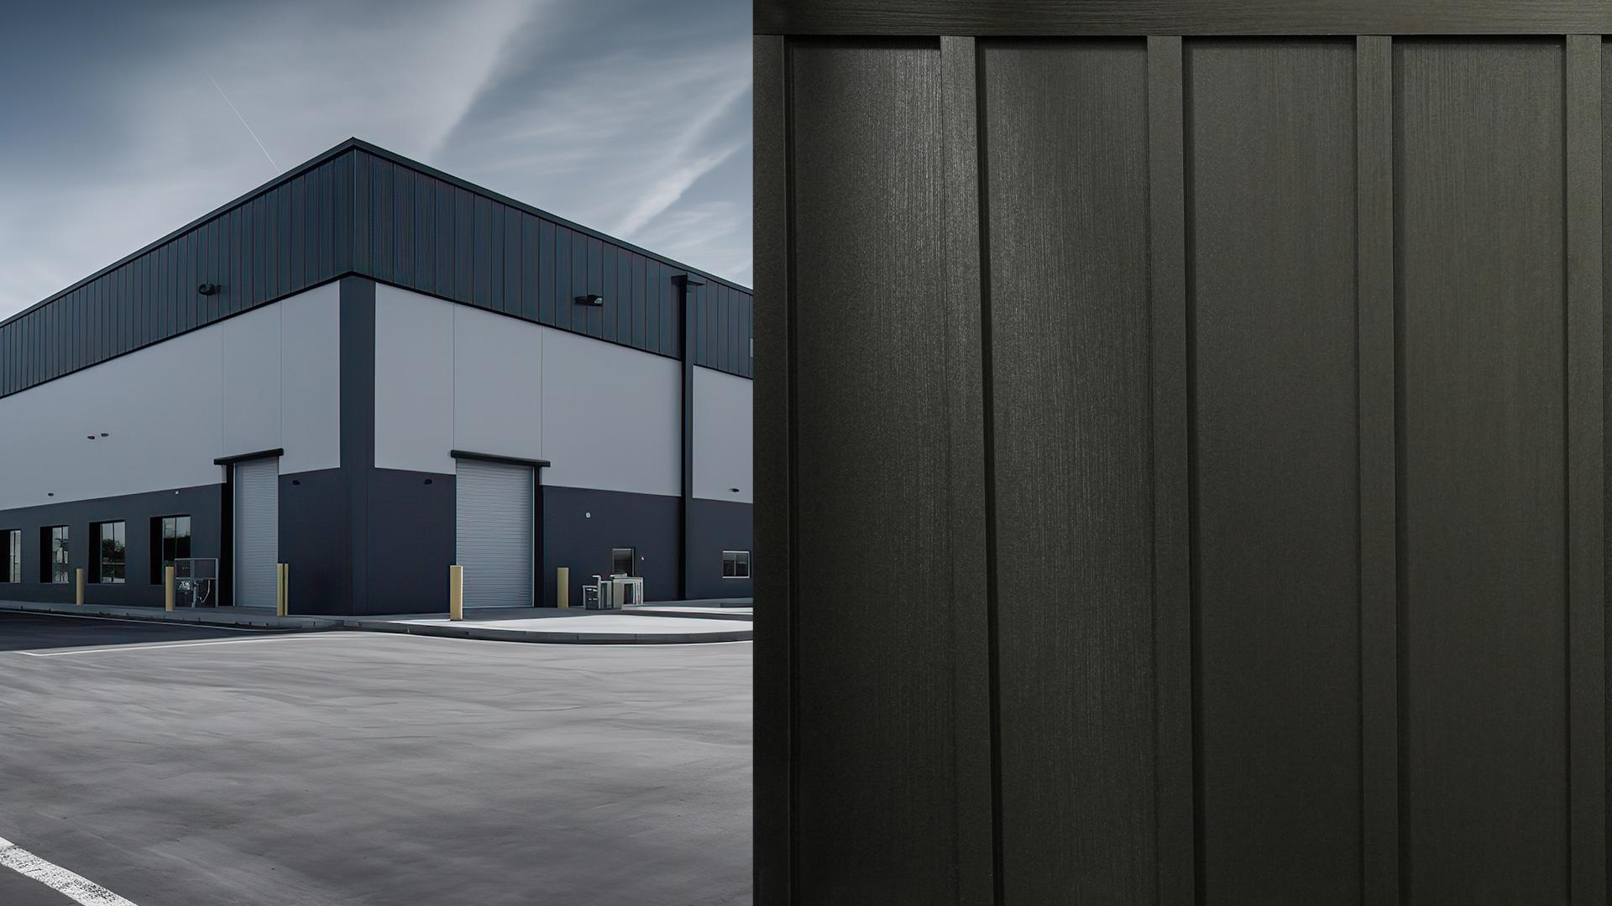
Western States Metal Roofing will begin manufacturing board and panel siding in early Fall, 2023. The manufacturer states that these siding panels will offer the same benefits as other metal siding panels offered on their website and will cost about the same as wood.

President of Western States Metal Roofing, Mike Rubio,”We get it – the challenges in the field are real when working with wood. That's why we've poured our expertise and innovation into creating a viable solution that makes your job easier, your designs more captivating, and your projects a testament to your skills.”

Mr. Rubio continues, “When it was time to decide which colors to include with board and batten, it was a simple choice to make, so we made our exclusive wood prints available to order with BB-12.0® board and batten. For architects who are just learning about the pitfalls of using wood in their design, by switching from wood to metal as your preferred choice for board and batten panels, you're not just catching up – you're leading the way into a new era of architectural design excellence.”

Board and batten panels are available in 24 gauge metal options and can also be ordered in .032 for aluminum panels. Board and batten is available with standard 12-inch coverage for the face of the board and 2-inch wide battens to cover the joints between panels. Board and batten is only offered as a concealed fastener panel and uses a nail strip fastening process. Panels can be ordered in lengths up to 30-feet maximum. Western States Metal Roofing is currently accepting pre-orders. Information about the new BB-12® Board and Batten panel can be found by visiting the manufacturer's website.

About Western States Metal Roofing
Western States Metal Roofing is an industry leader in manufacturing innovative metal roofing and siding solutions that redefine architectural possibilities. With an unwavering commitment to transcend the boundaries of conventional building design, Western States Metal Roofing empowers architects, roof contractors, and design-build firms to shape the future of modern architecture by harnessing the versatility and durability of metal building materials with unmatched aesthetics that spark creativity for building designs that embrace sustainable design principles. Visit us at www.westernstatesmetalroofing.com




