Never Seen Before Metal Siding Panels With Very Narrow Face Board Coverages Has Been Released By Popular Manufacturer

Without Notice Western States Metal Roofing Quietly Leaks What Looks To Be The Company’s Take On A Metal Version Of A Fence Board Panel

Phoenix, AZ (Aug 7, 2023): For over 20 years, Western States Metal Roofing, an industry leader in manufacturing unprecedented design innovations for metal cladding, has long been known among architects and contractors as a smaller sized metal manufacturer you could rely on when you need to purchase pre-painted metal roofing materials on the spot and with colors that match.

As of late, it has not gone unnoticed in the architectural design community that the company has grown in size and reputation. So, it should come to no surprise that the company’s new image is making waves. And when you log on to their new website, you can almost always expect something new.

If you recently visited the company’s website, chances are you may have missed the company’s latest product launch which was exclusively announced via a subscribers only email and by post to followers of their social media accounts. The announcement which looked to be a leaked prototype is now known on the construction scene as a haute metal version of a fence board.

So, without any further introduction, it is Western States Metal Roofing’s honor to introduce the metal industry’s first metal wall panel to boast some of the smallest standard face coverages in the metal market - cleverly labeled Narrow Groove®. These wall panels are offered in standard sizes with an 8” or 10” width. Some of the more notable attributes when compared to standard wood fence boards sold in local hardware stores include a 1” panel rib that measures the same height as the thickness of a wood board.

When asked about where you might find a narrow sized panel in architectural building design, Stacy Rubio, Vice President of Sales, provides more insight for typical uses, “You don’t see too many design flaws in modern buildings that weren’t intentional.”
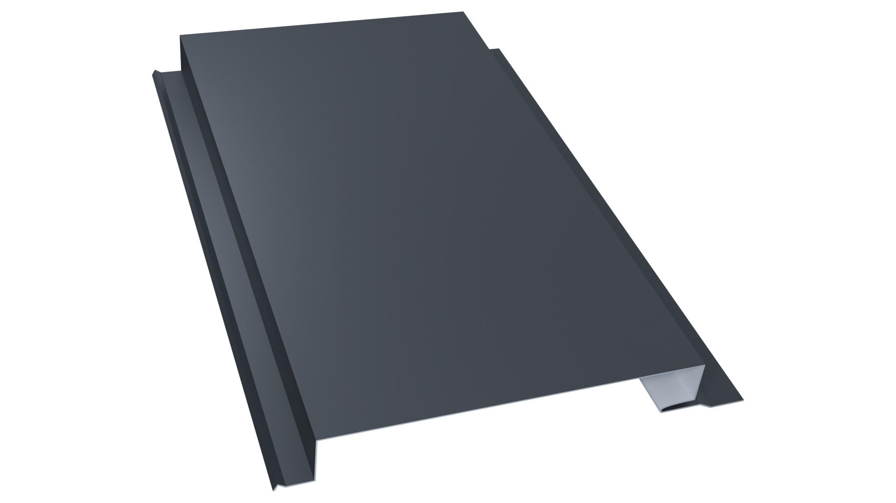
“And if you come across plans that require a narrow panel, there’s no longer a need to worry about costs related to customization. Instead with Narrow Groove® we’ve helped reduce projects costs by making a panel that was considered a custom width and made it standard”, Rubio goes on to state,”So the rule of thumb is, if you have a wall with a smaller area than the others, you want to use Narrow Groove® with a smaller face size so you can install a higher amount of panels which tricks the eye into thinking the walls are all using the same size panels.”

Narrow Groove® panels are available in 8" or 10" wide panels and can be custom made up to 20" wide panels. The manufacturer also warns, because T-Groove® panels closely resemble Narrow Groove®, each of these types of wall panels are independent fastening systems and are not interchangeable. For more detailed information about Narrow Groove, please visit the manufacturers website at www.westernstatesmetalroofing.com

About Western States Metal Roofing
Western States Metal Roofing is an industry leader in manufacturing innovative metal roofing and siding solutions that redefine architectural possibilities. With an unwavering commitment to transcend the boundaries of conventional building design, Western States Metal Roofing empowers architects, roof contractors, and design-build firms to shape the future of modern architecture by harnessing the versatility and durability of metal building materials with unmatched aesthetics that spark creativity for building designs that embrace sustainable design principles. Visit us at www.westernstatesmetalroofing.com

###

